spring 2025
Cse-4377 wireless communication systems
the university of texas at arlington


lab 3 report
Submitted toward the partial completion of the requirements for CSE 4377
Under the guidance of
Prof. Jason Losh
By:
Joshua Martinez, 1001374818

Introduction
This lab revolves around understanding loss within signals due to the length and type of cable carrying the signal. Three types of cables are used to measure and identify a dBm baseline of signal loss, or output, compared to a small RG316 as a reference. Thus, the first part of this lab is finding and recording these baseline values; afterwards, the next section requires the utilization and measuring of a HMC189, a miniature passive frequency doubler, with a change of signal output. Finally, the last part of the lab is running the previous three cables alongside the HMC189 and recording their values with the signal being doubled but with a longer cable distance to traverse. Through this lab, we will verify loss based on cables alone and the cables extended alongside the HMC189, comparing these different setups.

Steps 1 – 5: Reference Cable Baseline
To start with, both the RF Generator, configured with 100 MHz output and -20 dBm, and a Spectrum Analyzer, configured with a 100 MHz center frequency and 1 MHz span, are required. They will be connected via a short cable and the power received will be the reference for 100 MHz and will be repeated for the other values: 250 MHz, 1 GHz, 2 GHz, and 4 GHz. These measurements will be used to calibrate out the loss due to this cable when connecting and measuring the other three cables in future steps so we may purely contain the loss due to those cables alone. The following table shows the recorded values of the short cable, and the image depicts the SA outputting the first value when testing.

Short (Ref)
Freq. | Power (dBm)
100 MHz | -19 .82
250 MHz | -20.20
500 MHz | -20.43
1 GHz | -20.7
2 GHz | -21.82
4 GHz | -25.6
Table 1: Reference cable and its power output at certain frequencies
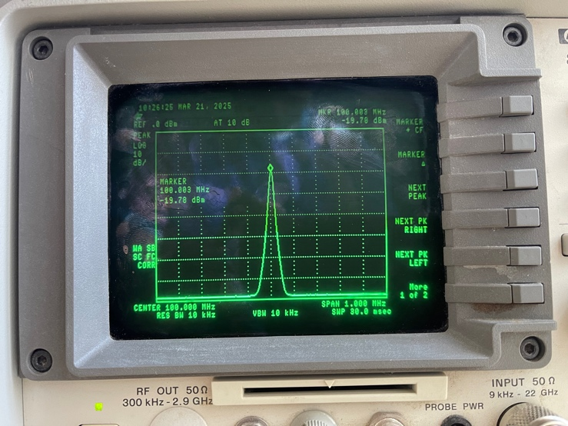
Image 1: Spectrum Analyzer receiving a 100MHz signa using reference cable

Step 6: Loss Measurements of Three Different Cables
The next step of the lab introduces three cables: a 6’ RG316 (brown), 3m UTiFlex UFA 210B (light green), 14’ Succoflex ½” HF (black) coax. They are to be attached, one at a time, between the Spectrum Analyzer and the short reference cable and will be measured similarly as the reference cable to capture the increased loss due to extending the signal length with these new additions. The following tables and images show our values during testing alongside reference loss values of the cables, except for the Succoflex coax cable as no proper documentation was found, from their manufacturers to evaluate the data next.
For the RG316 cable, it has a max loss of 11 dB per 100 ft, or an estimated -.11dB change per foot. Since we used a 6ft version, this loss is multiplied by 6 equating to an expected -.66 dB loss. When we compare this cable to the reference, it’ll be -20.46 to -19.82 or a .64 difference which is close to the expected loss. When we use the 1 GHz max loss, the expected loss per foot is 2.28 dB. The difference between this cable to the reference values is a 2.08 dB difference and is close to what we expect.
This process is to also be done to the UFA 210B cable. Using the chart for it, it notes about a 1 dB drop per 100ft at 1GHz, or a .01 dB difference per foot. The cable we used was 3m or about 9ft, equating to an expected drop of 09 dB. This cable measured -21.69 dBm whereas the reference cable had -20.7, or a .01 difference which is lower than expected but a good outcome overall. At 2 GHz, the cable notes a rough 15 dB/100ft or a .15 dB drop per foot equating to a 1.35 dB expected drop for our case. The UFA 210B cable had -23.69 dBm and -21.82 dBm was for the reference. Thus, the recorded drop was 1.87 dBm and is higher than the 1.35 dB expected loss, but this can be equated to a rough estimate at this frequency,
For the Succoflex coaxial cable, no definite datasheet was available to test the difference from it’s measured values to the reference, but the method used prior would be the same.

Frequency | 6' RG316 Power (dBm) | UTiFlex UFA 210B Power (dBm) | 14' Succoflex 1/2'' HF Power (dBm)
100 MHz | -20.46 | -20.18 | -20.07
250 MHz | -21.19 | -20.67 | -20.5
500 MHz | -21.83 | -21.07 | -20.85
1 GHz | -22.78 | -21.69 | -22.47
2 GHz | -25.01 | -23.69 | -23.36
4 GHz | -29.54 | -26.8 | -26.69

Table 2: The three types of cables with their power outputs at certain frequencies

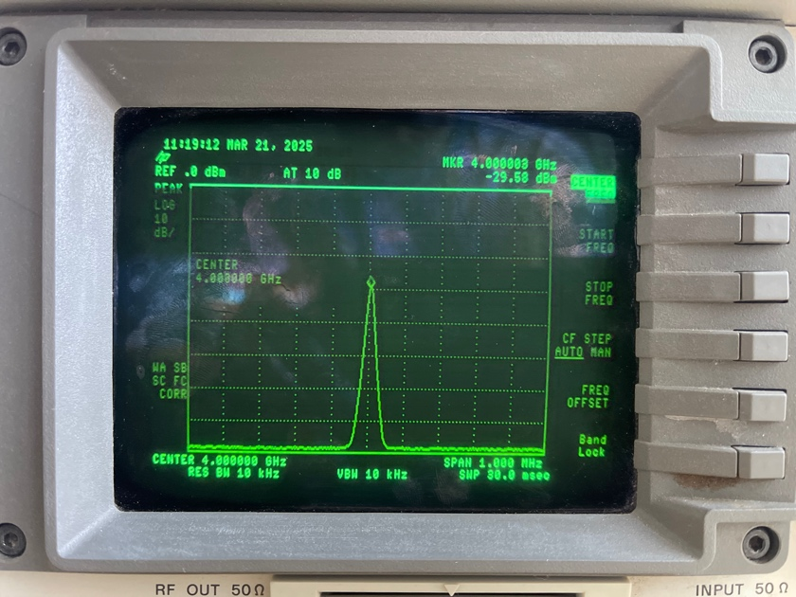
Image 2: 6' RG316 cable output on Spectrum Analyzer at 4GHz

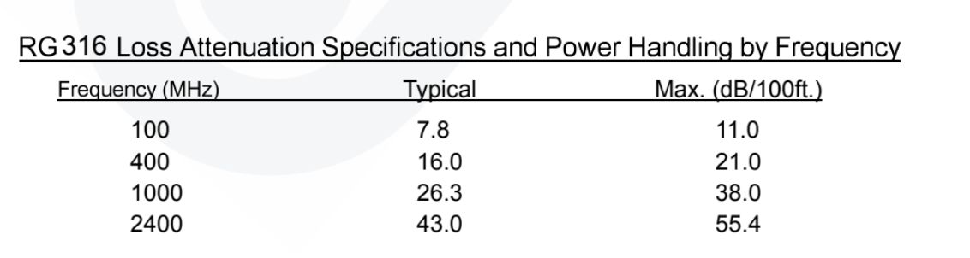
Image 3: 6’ RG316 datasheet snippet of its loss

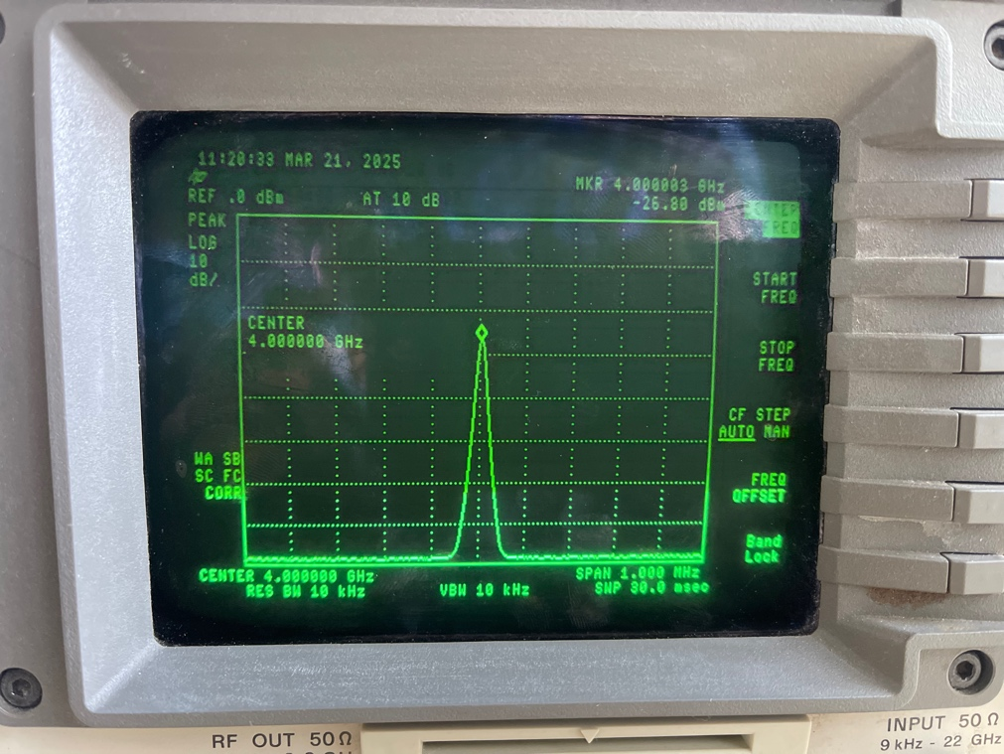
Image 4: UFA 210B cable output on Spectrum Analyzer at 4GHz

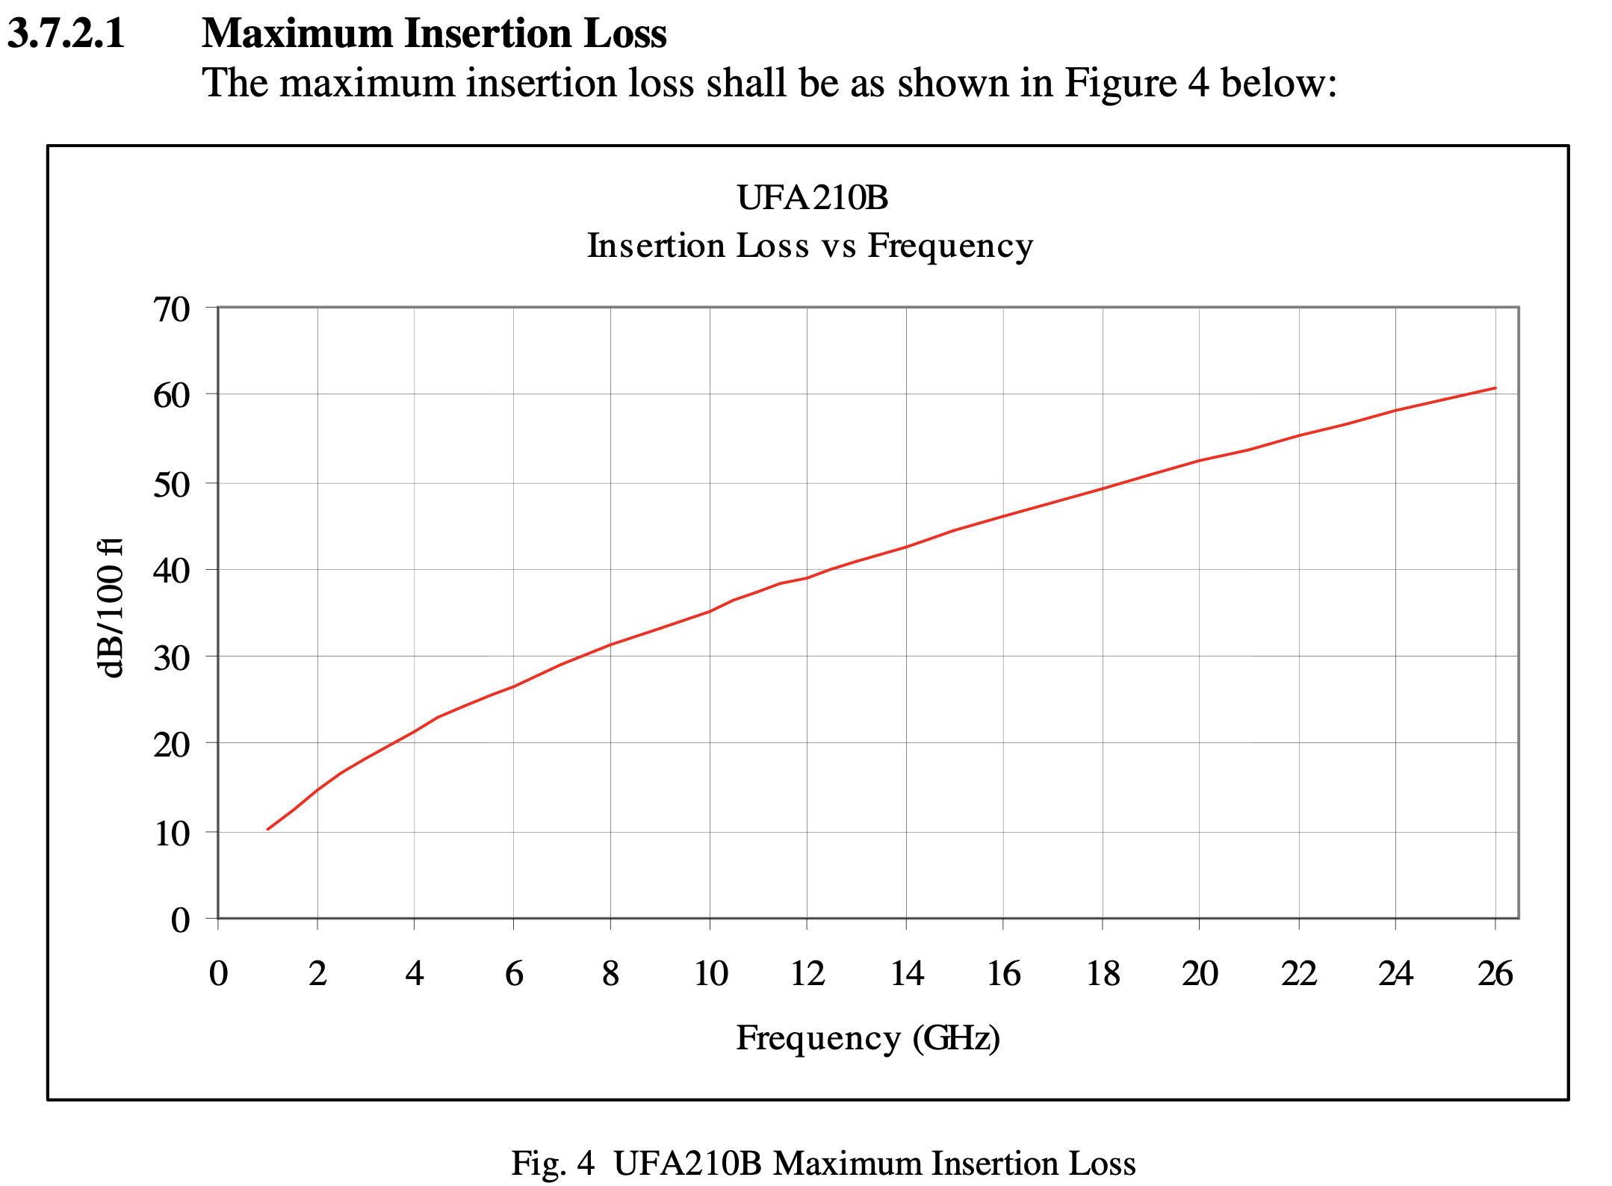
Image 5: UFA 210B datasheet snippet for max insertion loss

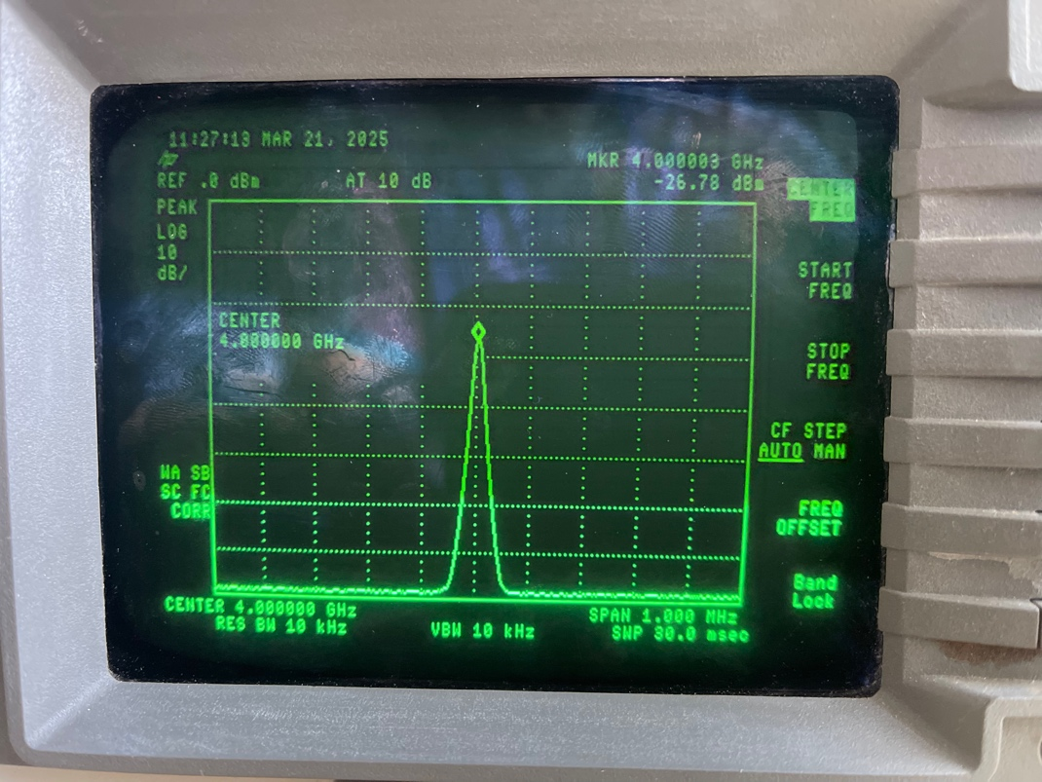
Image 6: 14' Succoflex cable output on Spectrum Analyzer at 4GHz

Steps 7 – 10: HMC189 Passive Frequency Doubler
The next steps for the lab introduce the HMC189 frequency doubler which, per its name, is used to generate an output signal with a frequency twice of the input. This module is placed between the Spectrum Analyzer and the reference cable. A 6” cable is required to connect back to the SA. During setup, we need to change the -20dBm output to 10 dBm. Due to the device doubling the frequency, the SA needs to be set at twice the frequency, for example, if the RF generator is at 2 GHz the Spectrum Analyzer needs to be at 4 GHz. This doubling of the output does lead to a great amount of conversion loss since the set +20 dBm is shown to be measured at -12.32 dBm through the setup. This section of the lab is completed when the chart below was filled with our measured values and will be used as a reference when we swap the 6” cable with the 3 previously used cables to measure their new loss with this setup.

6 inch RG316 (Ref)
Freq. | Power (dBm)
2 GHz | -12.32
3 GHz | -16.5
4 GHz | -27.66
Table 3: HMC189 frequency doubler and its power output at certain frequencies
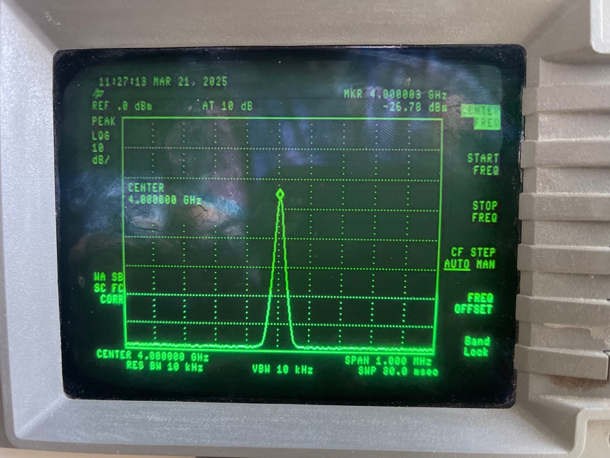
Image 7: HMC189 output on Spectrum Analyzer at 8GHz

Step 11: Loss Measurements of the Three Cables w/ HMC189
For the last part of the lab, we must record the power outputs measured of the three cables again but connected between the Spectrum Analyzer and the HMC189 with new frequency ranges. The table below shows our recorded data completing this section and a similar process to calculate the loss from the cables to the reference will be used.
For the RG316 cable, it had -19.63 dBm compared to the reference -12.32 dBm, or a 7.31 dB drop. The datasheet notes a max drop of 55.4 dB/100ft, or .554 dB/ft, at 2.4 which will be used to compare the 2 GHz power. Therefore, the drop is 3.324, but since the frequency is doubled this value will be doubled for an outcome of 6.648 difference, as the reference sheet doesn’t note higher than 2.4 GHz and therefore requires an estimated guess. Overall, this cable contains 0.662 dBm higher than expected but should be within reason for this cable.
Next is the 3m UFA 210B cable which has about 22 dB/100ft, or .22 dB/ft, loss at 4GHz which is to be compared to the reference 2 GHz. Their power values are -14.02 and -12.32 dBm, respectively, measuring a loss of 1.7 dB. Since the cable is 9ft, the expected loss is 1.98 and is .28 greater than measured but is within reason. At 4 GHz, this cable had a -29.24 dBm output whereas the reference had a dB output of -27.66, leading to a 1.58 dB drop. Using the chart on the datasheet at 8 GHz, 4 GHz doubled due to HMC189, there is a rough 32 dB/100ft drop, or .32 dB/ft. This leads to a 2.88 expected dB drop which is greater than our 1.58 dB actual drop which is a 1.3 dB greater outcome.
Finally, as mentioned for the Succoflex cable, no definite datasheet was found for this cable, but the comparing and deduction of dB loss would be done in a similar sense as the previous two cables and is the final step for this lab.

Freq. | 6' RG316 Power (dBm) | UTiFlex UFA 210B Power (dBm) | 14' Succoflex 1/2'' HF Power (dBm)
2 GHz | -19.63 | -14.02 | -15
3 GHz | -24.75 | -16.45 | -16.25
4 GHz | -36.09 | -29.24 | -28.7

Table 4: The three cables with their power outputs at certain frequencies using the HMC189

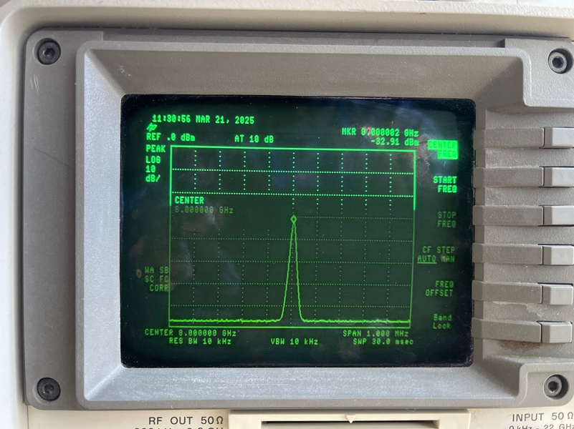
Image 8: RG316 w/ HMC189 output on Spectrum Analyzer at 8GHz

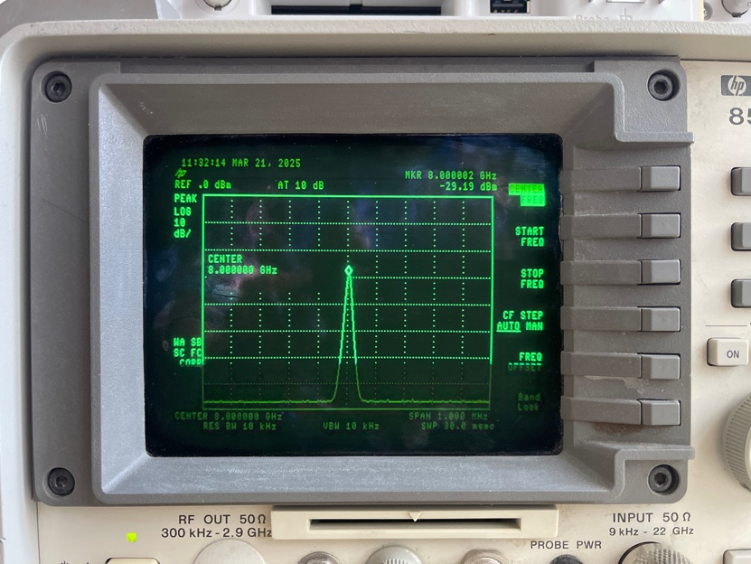

Image 9: UFA 210B w/ HMC189 output on Spectrum Analyzer at 8GHz

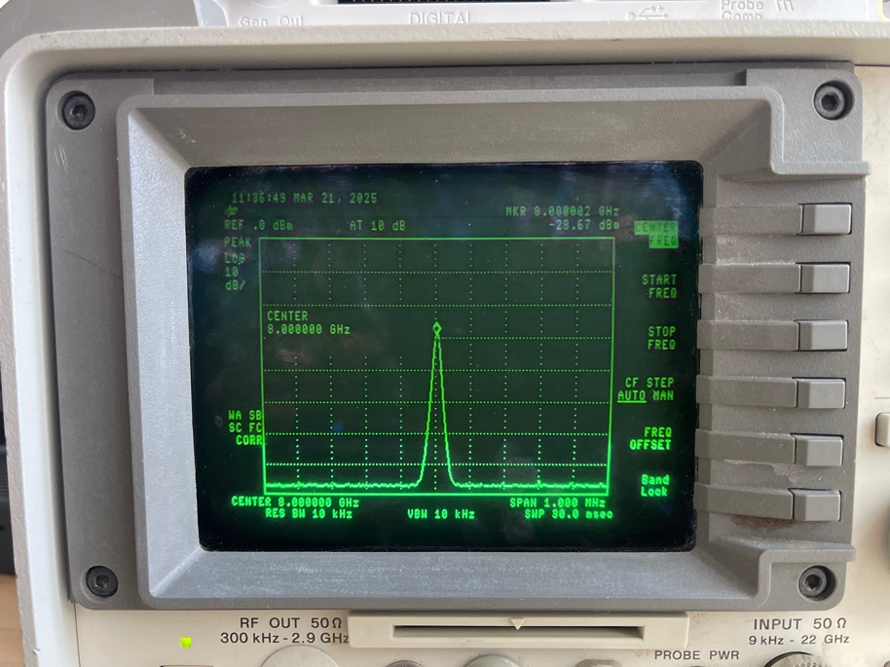
Image 10: Succoflex w/ HMC189 output on Spectrum Analyzer at 8GHz

Conclusion
In conclusion, this lab provided experience on signal loss based on three cables with unique builds and how they compare to one another. These tests were conducted by comparing the cables alone for the first part and with a frequency doubler with a cable extension for the second. Our experiment was to be verified using our recorded values and compare them to the datasheets of the cables, but we had trouble finding one for the Succoflex cable. Overall, this lab was to cover the importance of signal loss due to cables, putting their materials, length, and purpose as important factors when choosing them for future projects/builds.

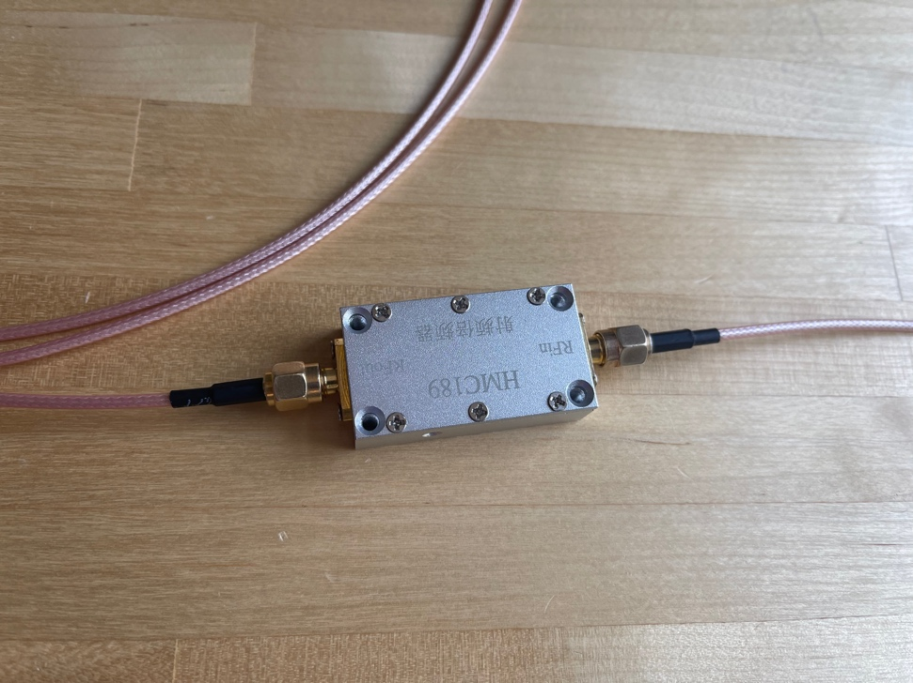
Image 11: Connection setup used for RG316 w/ HMC189

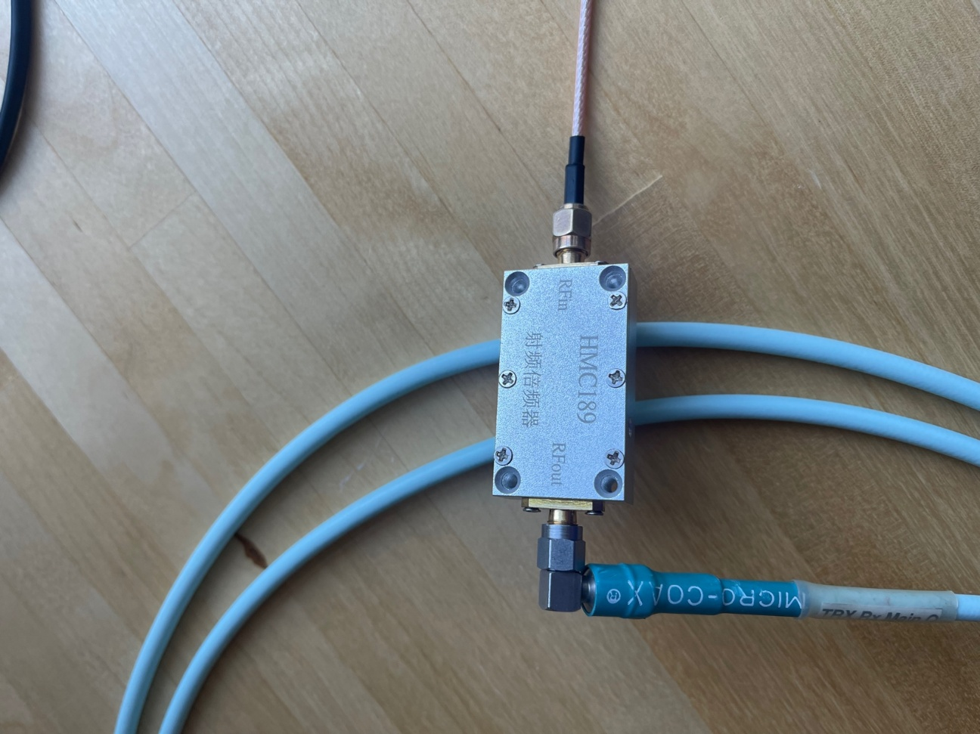
Image 12: Connection setup used for UFA w/ HMC189
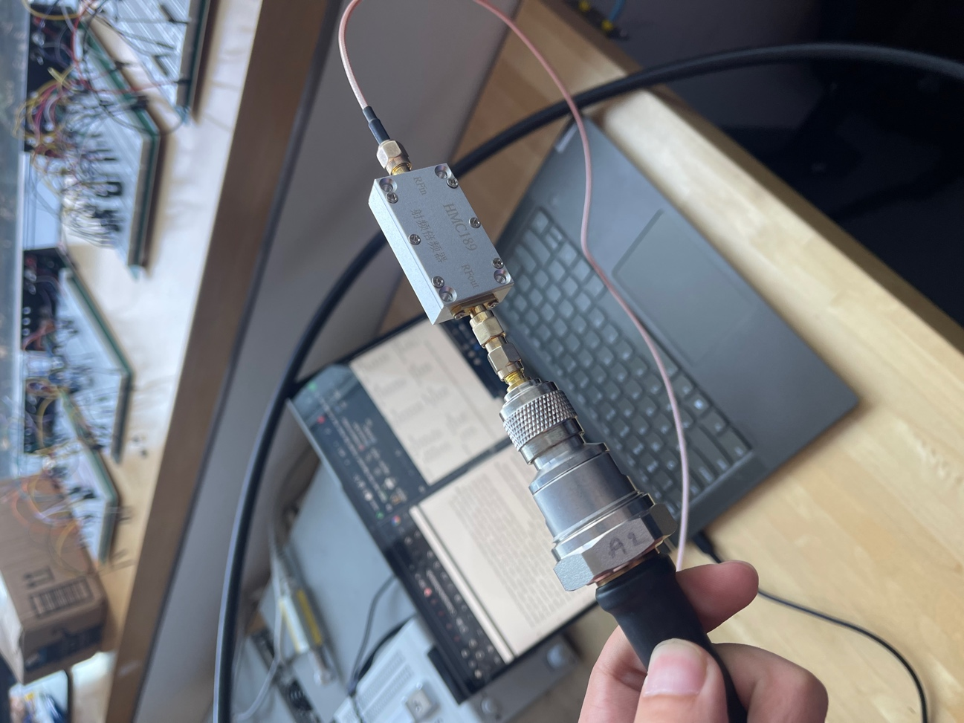
Image 13: Connection setup used for Succoflex w/ HMC189

